**EIGRP**

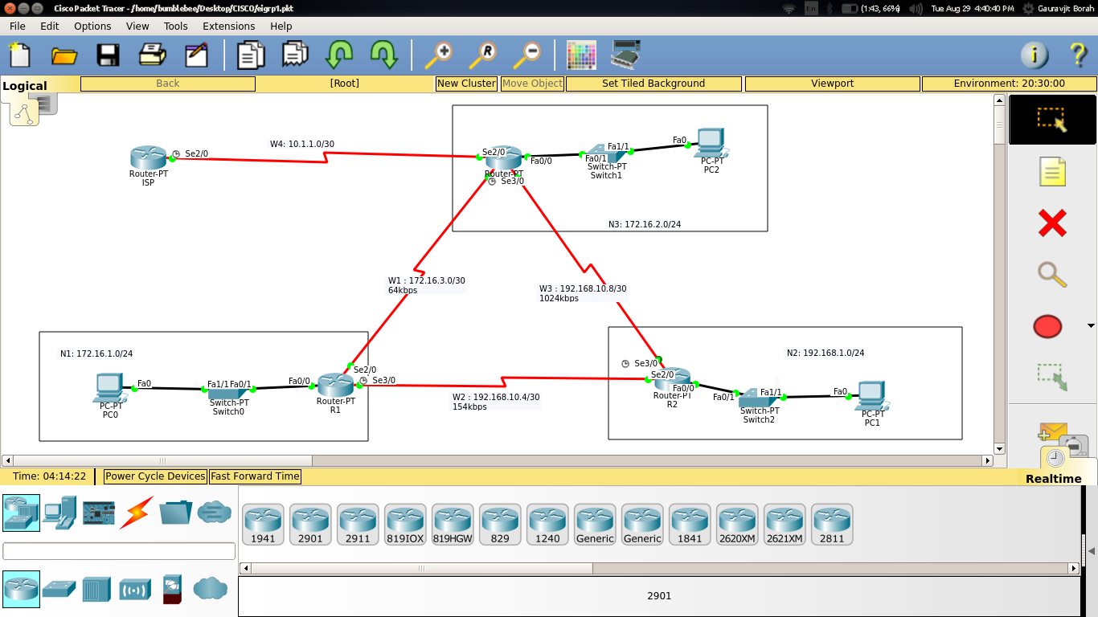

|  |  |  |  |  |  |  |  |
| --- | --- | --- | --- | --- | --- | --- | --- |
| **Name** | **N/k Addr** | **Subnet Mask** | **Wildcard Mask** | **CIDR** | **Default-Gateway** | **Host Addr Range** | **Broadcast Addr** |
| N1 | 172.16.1.0 | 255.255.255.0 | 0.0.0.255 | 24 | 172.16.1.1 | 172.16.1.1-172.16.1.254 | 172.16.1.255 |
| N2 | 192.168.1.0 | 255.255.255.0 | 0.0.0.255 | 24 | 192.168.1.1 | 192.168.1.1-192.168.1.254 | 192.168.1.255 |
| N3 | 172.16.2.0 | 255.255.255.0 | 0.0.0.255 | 24 | 172.16.2.1 | 172.16.2.1-172.16.2.254 | 172.16.2.255 |
| W1 | 172.16.3.0 | 255.255.255.252 | 0.0.0.3 | 30 | - | 172.16.3.1,172.16.3.2 | 172.16.3.3 |
| W2 | 192.168.10.4 | 255.255.255.252 | 0.0.0.3 | 30 | - | 192.168.10.5,192.168.10.6 | 192.168.10.7 |
| W3 | 192.168.10.8 | 255.255.255.252 | 0.0.0.3 | 30 | - | 192.168.10.9,192.168.10.10 | 192.168.10.11 |
| W4 | 10.1.1.0 | 255.255.255.252 | 0.0.0.3 | 30 | - | 10.1.1.1,10.1.1.2 | 10.1.1.3 |

**Router 1**

R1#show ip eigrp neighbors

IP-EIGRP neighbors for process 1

H Address Interface Hold Uptime SRTT RTO Q Seq

(sec) (ms) Cnt Num

0 192.168.10.6 Se3/0 12 00:04:45 40 1000 0 9

1 172.16.3.2 Se2/0 12 00:04:45 40 1000 0 18

R1#show ip eigrp topology

IP-EIGRP Topology Table for AS 1/ID(192.168.10.5)

Codes: P - Passive, A - Active, U - Update, Q - Query, R - Reply,

r - Reply status

P 10.1.1.0/30, 1 successors, FD is 21536000

via 192.168.10.6 (21536000/21024000), Serial3/0

via 172.16.3.2 (41024000/20512000), Serial2/0

P 172.16.1.0/24, 1 successors, FD is 28160

via Connected, FastEthernet0/0

P 172.16.3.0/30, 1 successors, FD is 40512000

via Connected, Serial2/0

P 192.168.1.0/24, 1 successors, FD is 17137920

via 192.168.10.6 (17137920/28160), Serial3/0

via 172.16.3.2 (41026560/3014400), Serial2/0

P 192.168.10.4/30, 1 successors, FD is 17135360

via Connected, Serial3/0

P 192.168.10.8/30, 1 successors, FD is 17647360

via 192.168.10.6 (17647360/3011840), Serial3/0

via 172.16.3.2 (41024000/3011840), Serial2/0

R1#show ip eigrp traffic

IP-EIGRP Traffic Statistics for process 1

Hellos sent/received: 229/150

Updates sent/received: 10/14

Queries sent/received: 0/0

Replies sent/received: 0/0

Acks sent/received: 14/9

Input queue high water mark 1, 0 drops

SIA-Queries sent/received: 0/0

SIA-Replies sent/received: 0/0

R1#show ip route

Codes: C - connected, S - static, I - IGRP, R - RIP, M - mobile, B - BGP

D - EIGRP, EX - EIGRP external, O - OSPF, IA - OSPF inter area

N1 - OSPF NSSA external type 1, N2 - OSPF NSSA external type 2

E1 - OSPF external type 1, E2 - OSPF external type 2, E - EGP

i - IS-IS, L1 - IS-IS level-1, L2 - IS-IS level-2, ia - IS-IS inter area

* - candidate default, U - per-user static route, o - ODR

P - periodic downloaded static route

Gateway of last resort is not set

10.0.0.0/30 is subnetted, 1 subnets

D 10.1.1.0 [90/21536000] via 192.168.10.6, 00:05:44, Serial3/0

172.16.0.0/16 is variably subnetted, 2 subnets, 2 masks

C 172.16.1.0/24 is directly connected, FastEthernet0/0

C 172.16.3.0/30 is directly connected, Serial2/0

D 192.168.1.0/24 [90/17137920] via 192.168.10.6, 00:05:46, Serial3/0

192.168.10.0/30 is subnetted, 2 subnets

C 192.168.10.4 is directly connected, Serial3/0

D 192.168.10.8 [90/17647360] via 192.168.10.6, 00:05:46, Serial3/0

**Router 2**

R2#show ip eigrp neighbors

IP-EIGRP neighbors for process 1

H Address Interface Hold Uptime SRTT RTO Q Seq

(sec) (ms) Cnt Num

0 192.168.10.5 Se2/0 11 00:06:29 40 1000 0 12

1 192.168.10.10 Se3/0 13 00:06:27 40 1000 0 19

R2#show ip eigrp topology

IP-EIGRP Topology Table for AS 1/ID(192.168.10.9)

Codes: P - Passive, A - Active, U - Update, Q - Query, R - Reply,

r - Reply status

P 10.1.1.0/30, 1 successors, FD is 21024000

via 192.168.10.10 (21024000/20512000), Serial3/0

P 172.16.1.0/24, 1 successors, FD is 17137920

via 192.168.10.5 (17137920/28160), Serial2/0

P 172.16.3.0/30, 2 successors, FD is 41024000

via 192.168.10.5 (41024000/40512000), Serial2/0

via 192.168.10.10 (41024000/40512000), Serial3/0

P 192.168.1.0/24, 1 successors, FD is 28160

via Connected, FastEthernet0/0

P 192.168.10.4/30, 1 successors, FD is 17135360

via Connected, Serial2/0

P 192.168.10.8/30, 1 successors, FD is 3011840

via Connected, Serial3/0

R2#show ip eigrp traffic

IP-EIGRP Traffic Statistics for process 1

Hellos sent/received: 291/192

Updates sent/received: 7/11

Queries sent/received: 0/0

Replies sent/received: 0/0

Acks sent/received: 11/7

Input queue high water mark 1, 0 drops

SIA-Queries sent/received: 0/0

SIA-Replies sent/received: 0/0

R2#show ip route

Codes: C - connected, S - static, I - IGRP, R - RIP, M - mobile, B - BGP

D - EIGRP, EX - EIGRP external, O - OSPF, IA - OSPF inter area

N1 - OSPF NSSA external type 1, N2 - OSPF NSSA external type 2

E1 - OSPF external type 1, E2 - OSPF external type 2, E - EGP

i - IS-IS, L1 - IS-IS level-1, L2 - IS-IS level-2, ia - IS-IS inter area

* - candidate default, U - per-user static route, o - ODR

P - periodic downloaded static route

Gateway of last resort is not set

10.0.0.0/30 is subnetted, 1 subnets

D 10.1.1.0 [90/21024000] via 192.168.10.10, 00:07:22, Serial3/0

172.16.0.0/16 is variably subnetted, 2 subnets, 2 masks

D 172.16.1.0/24 [90/17137920] via 192.168.10.5, 00:07:24, Serial2/0

D 172.16.3.0/30 [90/41024000] via 192.168.10.5, 00:07:24, Serial2/0

[90/41024000] via 192.168.10.10, 00:07:22, Serial3/0

C 192.168.1.0/24 is directly connected, FastEthernet0/0

192.168.10.0/30 is subnetted, 2 subnets

C 192.168.10.4 is directly connected, Serial2/0

C 192.168.10.8 is directly connected, Serial3/0

**Router 3**

R3#show ip eigrp neighbors

IP-EIGRP neighbors for process 1

H Address Interface Hold Uptime SRTT RTO Q Seq

(sec) (ms) Cnt Num

0 10.1.1.2 Se2/0 12 00:09:04 40 1000 0 19

1 172.16.3.1 Se3/0 11 00:09:03 40 1000 0 11

2 192.168.10.9 Se6/0 11 00:09:01 40 1000 0 10

R3#show ip eigrp topology

IP-EIGRP Topology Table for AS 1/ID(192.168.10.10)

Codes: P - Passive, A - Active, U - Update, Q - Query, R - Reply,

r - Reply status

P 10.1.1.0/30, 1 successors, FD is 20512000

via Connected, Serial2/0

P 172.16.1.0/24, 1 successors, FD is 17649920

via 192.168.10.9 (17649920/17137920), Serial6/0

via 172.16.3.1 (40514560/28160), Serial3/0

P 172.16.3.0/30, 1 successors, FD is 40512000

via Connected, Serial3/0

P 192.168.1.0/24, 1 successors, FD is 3014400

via 192.168.10.9 (3014400/28160), Serial6/0

P 192.168.10.4/30, 1 successors, FD is 17647360

via 192.168.10.9 (17647360/17135360), Serial6/0

via 172.16.3.1 (41024000/17135360), Serial3/0

P 192.168.10.8/30, 1 successors, FD is 3011840

via Connected, Serial6/0

R3#show ip eigrp traffic

IP-EIGRP Traffic Statistics for process 1

Hellos sent/received: 362/359

Updates sent/received: 23/16

Queries sent/received: 0/0

Replies sent/received: 0/0

Acks sent/received: 13/23

Input queue high water mark 1, 0 drops

SIA-Queries sent/received: 0/0

SIA-Replies sent/received: 0/0

R3#show ip route

Codes: C - connected, S - static, I - IGRP, R - RIP, M - mobile, B - BGP

D - EIGRP, EX - EIGRP external, O - OSPF, IA - OSPF inter area

N1 - OSPF NSSA external type 1, N2 - OSPF NSSA external type 2

E1 - OSPF external type 1, E2 - OSPF external type 2, E - EGP

i - IS-IS, L1 - IS-IS level-1, L2 - IS-IS level-2, ia - IS-IS inter area

* - candidate default, U - per-user static route, o - ODR

P - periodic downloaded static route

Gateway of last resort is not set

10.0.0.0/30 is subnetted, 1 subnets

C 10.1.1.0 is directly connected, Serial2/0

172.16.0.0/16 is variably subnetted, 3 subnets, 2 masks

D 172.16.1.0/24 [90/17649920] via 192.168.10.9, 00:09:13, Serial6/0

C 172.16.2.0/24 is directly connected, FastEthernet0/0

C 172.16.3.0/30 is directly connected, Serial3/0

D 192.168.1.0/24 [90/3014400] via 192.168.10.9, 00:09:13, Serial6/0

192.168.10.0/30 is subnetted, 2 subnets

D 192.168.10.4 [90/17647360] via 192.168.10.9, 00:09:13, Serial6/0

C 192.168.10.8 is directly connected, Serial6/0

**Router 4 (ISP)**

ISP>show ip eigrp neighbors

IP-EIGRP neighbors for process 1

H Address Interface Hold Uptime SRTT RTO Q Seq

(sec) (ms) Cnt Num

0 10.1.1.1 Se2/0 12 00:09:52 40 1000 0 18

ISP>show ip eigrp topology

IP-EIGRP Topology Table for AS 1/ID(10.1.1.2)

Codes: P - Passive, A - Active, U - Update, Q - Query, R - Reply,

r - Reply status

P 10.1.1.0/30, 1 successors, FD is 20512000

via Connected, Serial2/0

P 172.16.1.0/24, 1 successors, FD is 21538560

via 10.1.1.1 (21538560/17649920), Serial2/0

P 172.16.3.0/30, 1 successors, FD is 41024000

via 10.1.1.1 (41024000/40512000), Serial2/0

P 192.168.1.0/24, 1 successors, FD is 21026560

via 10.1.1.1 (21026560/3014400), Serial2/0

P 192.168.10.4/30, 1 successors, FD is 21536000

via 10.1.1.1 (21536000/17647360), Serial2/0

P 192.168.10.8/30, 1 successors, FD is 21024000

via 10.1.1.1 (21024000/3011840), Serial2/0

ISP>show ip eigrp traffic

IP-EIGRP Traffic Statistics for process 1

Hellos sent/received: 133/132

Updates sent/received: 10/9

Queries sent/received: 0/0

Replies sent/received: 0/0

Acks sent/received: 9/8

Input queue high water mark 1, 0 drops

SIA-Queries sent/received: 0/0

SIA-Replies sent/received: 0/0

ISP>show ip route

Codes: C - connected, S - static, I - IGRP, R - RIP, M - mobile, B - BGP

D - EIGRP, EX - EIGRP external, O - OSPF, IA - OSPF inter area

N1 - OSPF NSSA external type 1, N2 - OSPF NSSA external type 2

E1 - OSPF external type 1, E2 - OSPF external type 2, E - EGP

i - IS-IS, L1 - IS-IS level-1, L2 - IS-IS level-2, ia - IS-IS inter area

* - candidate default, U - per-user static route, o - ODR

P - periodic downloaded static route

Gateway of last resort is not set

10.0.0.0/30 is subnetted, 1 subnets

C 10.1.1.0 is directly connected, Serial2/0

172.16.0.0/16 is variably subnetted, 2 subnets, 2 masks

D 172.16.1.0/24 [90/21538560] via 10.1.1.1, 00:10:02, Serial2/0

D 172.16.3.0/30 [90/41024000] via 10.1.1.1, 00:10:05, Serial2/0

D 192.168.1.0/24 [90/21026560] via 10.1.1.1, 00:10:02, Serial2/0

192.168.10.0/30 is subnetted, 2 subnets

D 192.168.10.4 [90/21536000] via 10.1.1.1, 00:10:02, Serial2/0

D 192.168.10.8 [90/21024000] via 10.1.1.1, 00:10:02, Serial2/0